**ASSIGNMENT COVERSHEET**

|  |  |  |  |  |  |  |  |
| --- | --- | --- | --- | --- | --- | --- | --- |
| **UTS: ENGINEERING & INFORMATION TECHNOLOGY** | | | | | | | |
| **SUBJECT NUMBER & NAME** | **NAME OF STUDENT(s)** (PRINT CLEARLY)  *YAFIE FARABI*  *SURNAME FIRST NAME* | | | | | | **STUDENT ID(s)**  14458044 |
| **STUDENT EMAIL**  Yafie.farabi@student.uts.edu.au | | | | **STUDENT CONTACT NUMBER**  0431 432 649 | | | |
| **NAME OF TUTOR**  **Shamim Hajhashemi** | | | **TUTORIAL GROUP**  **Group 1** | | | **DUE DATE**  **4th May 2025** | |
| **ASSESSMENT ITEM NUMBER & TITLE**  Assessment Task 3 Design Project | | | | | | | |
| I acknowledge that if AI or another nonrecoverable source was used to generate materials for background research and self-study in producing this assignment, I have checked and verified the accuracy and integrity of the information used.  I confirm that I have read, understood and followed the guidelines for assignment submission and presentation on page 2 of this cover sheet.  I confirm that I have read, understood and followed the advice in the Subject Outline about assessment requirements.  I understand that if this assignment is submitted after the due date it may incur a penalty for lateness unless I have previously had an extension of time approved and have attached the written confirmation of this extension.  **Declaration of originality**: The work contained in this assignment, other than that specifically attributed to another source, is that of the author(s) and has not been previously submitted for assessment. I have rewritten any material provided by AI or other nonrecoverable sources and where appropriate acknowledged their contribution. I understand that, should this declaration be found to be false, disciplinary action could be taken and penalties imposed in accordance with University policy and rules. In the statement below, I have indicated the extent to which I have collaborated with others, whom I have named.  No content generated by AI technologies or other sources has been presented as my own work and I have rewritten any text provided by AI or other sources in my own words.  **Statement of collaboration**:  **Signature of student(s) ____________________________________________________________ Date** **_________________________** | | | | | | | |
| - -- - - - - - - - - - - - - - - - - - - - - - - - - - - - - - - - - - - - - - - - - - - - - - - - - - - - - - - - - - - - - - - - - - - - - - - - - - - - - - - - - - - - - - - - - - - - - - - - - - - - | | | | | | | |
| **ASSIGNMENT RECEIPT** | | | | To be completed by the student if a receipt is required | | | |
| **SUBJECT NUMBER & NAME** | | **NAME OF TUTOR** | | | | | |
| **SIGNATURE OF TUTOR** | | | | | **RECEIVED DATE** | | |
|  | | | | |  | | |

|  |  |
| --- | --- |
| **STYLE GUIDE for ASSIGNMENT SUBMISSION**  Before submitting an assignment, you should refer to the policies and guidelines set out in the following:   * [FEIT Student Guide](http://www.uts.edu.au/sites/default/files/FEIT%20Student%20Guide.pdf) * [UTS Library - referencing](http://www.lib.uts.edu.au/help/referencing) * [HELPS - English and academic literacy support](http://www.uts.edu.au/current-students/support/helps/about-helps) * [UTS GSU - coursework assessment policy and procedures](http://www.gsu.uts.edu.au/policies/assessment-coursework.html) | |
| Unless your Subject Coordinator has indicated otherwise in the Subject Outline, you must follow the instructions below for submission of assignments in the Faculty of Engineering and Information Technology.  **Writing style**  It is usually best to write your initial draft in the default settings of your software without formatting. Use the following guides in your writing.  **Purpose and audience**: use the correct genre and language style expected for the particular task.  **Language**: use ‘plain English’ for all technical writing. More information about this language style can be found at [www.plainenglish.co.uk/free-guides.html](http://www.plainenglish.co.uk/free-guides.html).  Use spelling and grammar software tools to check your writing. Edit your document.  **Standards**: always use:   * Australian spelling standards (Macquarie Dictionary) * SI (International System of Units) units of measurement * ISO (International Organisation for Standardisation) for writing dates and times for international documents. For example **yyyy-mm-dd** or **hh-mm-ss**. However, for most applications it is more helpful to present the date in full as **26 August 2016**.   **Graphics and tables** should:   * be numbered * have an appropriate heading and/or caption * be fully labelled * be correctly referenced.   **Presentation**  Unless otherwise instructed, all assignment submissions should be **word processed** using spell-check and grammar-check software. Work should be well **edited** before submission. Use the following default settings:  **Page setup**: set margins at no less than 20mm all around.  **Paper**: print on A4 bond, double-spaced and preferably double-sided, left justified. | **Font**: use the software default style to provide consistency. The recommended style includes:   * 10-12 pt font * consistent formatting with a limited number of fonts * lines no more than 60 characters (use wider margins or columns if you need to make lines shorter)   **Header** should include:   * + your name and student number   + the title of the paper or task.   **Footer** should include the page number and current date.  Cover sheet and statement of originality: all work submitted for assessment must be the original work of the student(s) submitting the work. A standard faculty cover sheet (see over) must be attached to the front of the submission. Any collaboration between the submitting student and others must be declared on the cover sheet.  **Referencing**  All sources of information used in the preparation of your submission must be acknowledged using the APA system of referencing. This includes all print, video, electronic sources.  Phrases, sentences or paragraphs taken verbatim from a source must be in quotation marks and the source(s) cited using both **in-text** referencing and a **reference list**.  Plagiarism is the failure to acknowledge sources of information. You should be fully aware of the meaning of plagiarism and its consequences both to your marks, position at the university and criminal liability. The plagiarism in your assignment submissions can be assessed both in hard copy and in soft copy through software such as Turnitin.  The UTS Library and UTS HELPS (web links above) provide extensive information for students on referencing correctly to support you in avoiding plagiarism. |

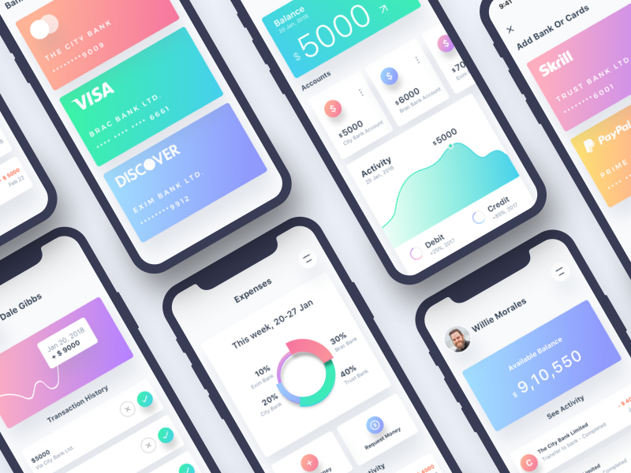

# Introduction

Assessment 3

Paper Prototype & Usability Report

14458044 – Yafie Farabi

This section of the report will be identical to the other members of your group.

Introduce your project starting with a presentation of the problem identified. You may want to make reference to the activities conducted through your research and definition stages (e.g. desktop research, interviewing, affinity diagramming, problem identification and target user group). Present your proposed conceptual design (i.e. your further developed idea after the design pitch). Recommended section length: up to 500 words.

In today’s digital age, prolonged sitting, poor posture, and the absence of regular breaks have become common issues among remote workers and creative professionals. Our research, which included desktop studies and user interviews, highlighted a recurring pattern: individuals engaged in screen-intensive work, such as freelance digital artists and remote employees, often fall into unhealthy sedentary routines. This behaviour contributes to a range of physical and mental challenges, including back and neck pain, fatigue, and diminished productivity.

One of the key problems identified during our early research was the lack of structured reminders or external cues to prompt users to move, stretch, or alternate between sitting and standing positions. Many users expressed that once they enter a state of “flow” or deep concentration, they lose track of time and forget to take necessary breaks. Additionally, while some users attempt to set their own timers or routines, they often fail to maintain these due to distractions, such as mobile notifications, social media, or overlapping calendar events.

Through affinity diagramming and persona development, we crafted a primary user profile to guide our design direction. Our main persona Ethan, a freelance digital illustrator mirrors the pain points uncovered in our research. Ethan typically works long hours at his desk, lacks a structured daily routine, and experiences symptoms of burnout. He occasionally uses basic timers but finds them ineffective in maintaining a consistent sitting/standing balance. His story informed the core goals of our proposed solution.

To address these issues, we developed a conceptual design for a smart desk companion app. The app enables users to create or import personalized sit/stand schedules tailored to their individual workflows. By incorporating sensors built into a smart desk, the system detects prolonged inactivity and provides gentle reminders to prompt physical movement. One of the standout features is its calendar integration allowing users to sync their preferred sit/stand intervals with existing schedules on platforms like Google Calendar. This ensures their wellness routines remain aligned with meetings and daily obligations.

Following our initial design pitch, we received valuable feedback from the user, which informed our subsequent refinements. We focused on improving usability by enhancing visual clarity such as including progress bars to show daily activity goals and simplifying interactions through drag-and-drop interfaces for custom scheduling. We also prioritised flexibility, ensuring the system supports users with irregular routines, including night workers or part-time creatives, through a customizable 24-hour timeline.

Overall, our conceptual design aims to promote healthier digital work habits through intuitive, non-intrusive, and customizable solutions. This report documents the next stage of our process: evaluating the usability of our paper prototype through structured user testing. By observing users interacting with the design and mapping their experience to established usability heuristics, we aim to identify both strengths and areas for improvement. The insights gained from this evaluation will guide further refinements, ensuring that our app remains user-centered and effective in supporting the well-being of its target audience.

**Section 1: Persona**

This section of the report will be identical to the other members of your group.

Present the persona in full size. Turn the page to landscape orientation if needed.

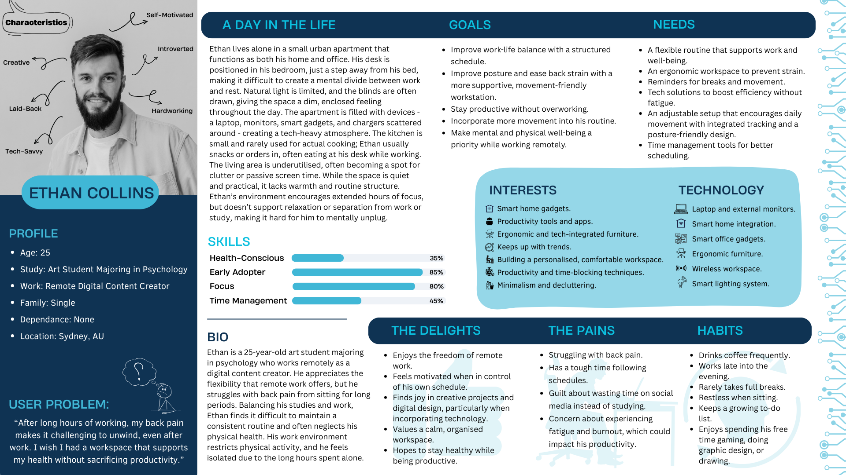

**Section 2: Problem Scenario**

This section of the report will be identical to the other members of your group.  
  
This is where you need to write your problem scenario. Showcase what the problem is and how it impacts the persona’s wellbeing. This is where you should show why this is such an issue and why it needs to be solved. This scenario should be no longer than 300 words.

I sit down in my chair and relax for a bit while I take in what I need to do for the day. When I think about how much work I have to do and how long I have to be sitting down for, I get worried and a little stressed about how much work there is and if I'll be ok sitting down for so long. Even though I can make it through most days just fine, it's really exhausting and draining though afterwards. It's really difficult to manage my time when I feel so much pressure on myself to get everything done as soon as I can so that I don't have to worry about it later but it just never ends. I don't know what I can do other than keep working until it's gone. I've even been having trouble making time for food breaks, let alone exercise, and it just gets worse when I waste my time on youtube or instagram instead of working. It's just a spiral that never feels like it's getting better. Doing the work sometimes cheers me up because I love doing digital art even when it's for work, and I enjoy watching videos too but I feel like I'll eventually burn out on everything because I just want to do it so much too. My posture has also been getting really bad recently since I have to sit still so much focused on a screen, I can barely get up off the chair sometimes after I finish. I feel like I've tried everything to keep myself on a schedule but nothing seems to work, and I live alone so I don't have anyone to help me with it either.

**Section 2: Future Use Scenario**

This section of the report will be identical to the other members of your group.

This is where you need to write your Future Use scenario. Showcase how your introduced design solution can improve the persona’s wellbeing and tackle the problem they face as shown in the problem scenario. This scenario should be no longer than 300 words.

I start everyday at the same time, not too early in the morning because I can work from home, so usually I start at 9am. Sometimes, I even stay in bed a little after my phone gives me a notification to wake up for the day and eat breakfast, but usually I start then. Afterwards, I walk over to my desk and open up the laptop, while also checking my day's schedule on my phone. Feeling confident with the workload I've got set for the day, I go through my to do list as they alert me on my phone. I've since corrected my bad work habits thanks to the desk's sensors telling me when I'm acting too anxious working. After a couple hours, my phone gives me forewarning before the desk lowers itself for the scheduled break for the day, and usually I decide to either exercise and make a small snack, or drag a chair over to have a quick break on social media or draw a little. I've been feeling really healthy and on top of things ever since I've been able to follow the schedules I've set, and the table enforcing the schedule alongside phone notifications really feels like someone tapping on my shoulder and helping me along my day. It's really reassuring. Since I started to following the schedule I set for myself, I feel like my workload has become so much lighter and manageable even though nothing has changed. Sometimes I even feel like I can squeeze some meetups with friends in-between my schedule.

**Section 3: Storyboard**

This section of the report will be identical to the other members of your group.

Present the storyboard in full size. Turn the page to landscape orientation if needed.

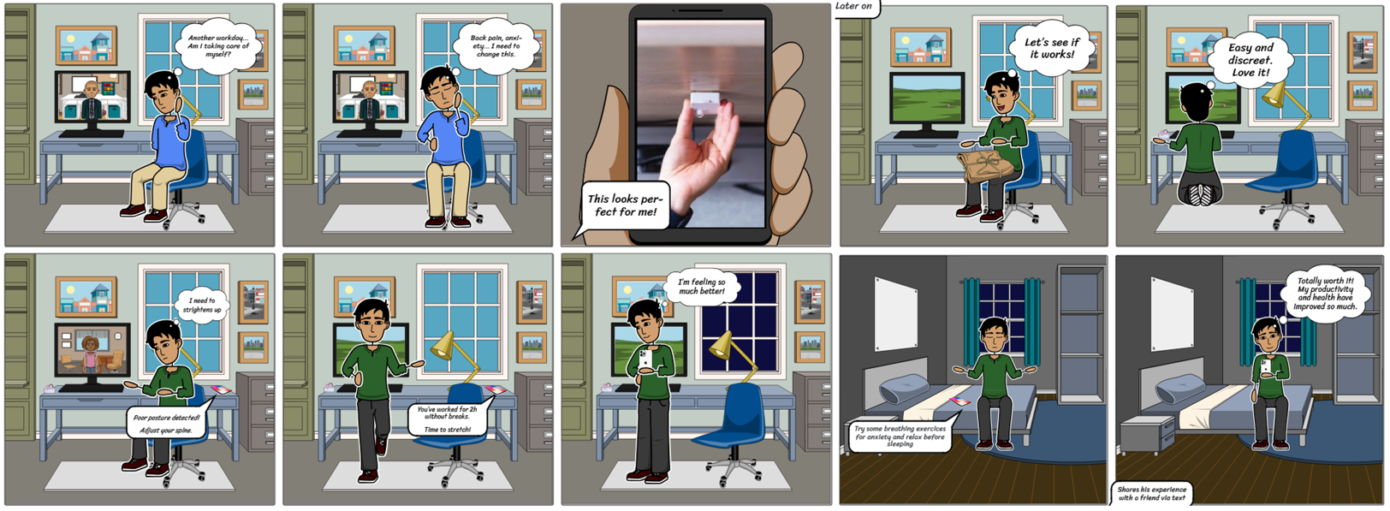

# Section 4: Specified Goal

This section of the report will be identical to the other members of your group.

Write what the user goal is (this should be an instruction that is given to the test user). A shorter summarised version will be presented on the Heuristics Evaluation Sheet (also the same for all members of the group).

You can also include a very short paragraph on a user context – a brief breakdown of the solution itself / the position the user is in*. E.g. the user is already a registered user of this app (a sign-in is only required)*

To setup or import a personalized sit/stand schedule for the smart standing desk for the week, and setup preferences for the built in activity sensor.

**Section 5: Prototype Evaluation**

Include a link to your video (hosted on YouTube, Vimeo, etc). If the video is password protected, you must include the password here.

Remember to show the face of your participant (tester) at the beginning, before starting the prototype test, as evidence of the test being conducted by an actual participant. The video must not be longer than 5 minutes.

<https://youtu.be/-3afljHxYKA>

**HEURISTIC EVALUATION SHEET**

|  |  |  |  |  |
| --- | --- | --- | --- | --- |
| Evaluator name (you): | Yafie Farabi |  | User’s name (participant): | Afifa Marzana |
| Date: | 28th April 2025 |  | User's Goal (from section 4): | To setup or import a personalized sit/stand schedule for the smart standing desk for the week, and setup preferences for the built in activity sensor. |
|  |  |  |  |  |

|  |  |  |  |  |  |  |  |
| --- | --- | --- | --- | --- | --- | --- | --- |
| **List of heuristics** | |  | |  | |  | |
|  |  | | 1. Match system to the real world | | 6. Aesthetic/minimal design | |
|  |  | | 2. Consistency & standards | | 7. Recognition, not recall (minimise demands on human memory) | |
|  |  | | 3. Visibility of system status & feedback | | 8. Help users with errors & recovery | |
|  |  | | 4. Error prevention | | 9. Flexible/ efficiency of use | |
|  |  | | 5. User sense of control & freedom | | 10. Help & documentation | |

|  |  |  |  |  |  |
| --- | --- | --- | --- | --- | --- |
|  | **USABILITY ASSESSMENT**  Summarise positive and negative finding(s) observed and include: - page/screen where finding was observed - the specific part of the task the user was doing when it occurred | **IDENTIFICATION OF HEURISTICS**  For each finding specify which heuristics were violated (V) or complied with (C). Refer to the list of heuristics above. | **EXPLANATION OF HEURISTICS**  Explain how the heuristics are violated or complied with, indicating the cause and referring to specific design aspects of the interface | **USABILITY IMPACT**  Explain how the observed findings impacted on the user experience & task completion | **USABILITY SUGGESTION(S)**  Suggest at least one interface design intervention per screen to rectify the issue or improve the experience even more. |
| **Screen/State 1** | Screen 1 – Main Menu (Dashboard):   * Positive: The user immediately understood their status, "pause" function, and weekly progress. * Task step: First arrival at Dashboard after logging in. | - (C) 1: Visibility of system status  - (C) 3: User control and freedom | Clear status indicators (progress bars, pause button) show system status (H1) and allow user control (H3). | User felt confident and oriented, facilitating a smooth start. | Add a summary icon next to "Summary" text to speed up visual recognition. |
| **Screen/State 2** | Screen 2 – Create New Schedule:  Negative: The user hesitated between "Create New" and "Import" buttons.  Task step: Setting up a new schedule. | (V) 7: Flexibility and efficiency of use | Lack of descriptions under buttons confused the user (H7). | User paused unnecessarily, slowing down task completion. | Add one-line tooltips under each button ("Start from scratch" / "Use existing calendar"). |
| **Screen/State 3** | Screen 3 – Weekly Schedule Setup:  Positive: Weekly calendar view felt intuitive and natural.  Task step: Selecting active days and times. | (C) 1: Visibility of system status  (C) 6: Recognition rather than recall | Familiar calendar layout made options visible (H1) and minimized memory load (H6). | Fast, accurate task performance. | Allow click-and-drag selection across multiple days to improve speed even further. |
| **Screen/State4** | Screen 4 – Daily View:  Negative: User felt restricted by time blocks (no 24-hour setup).  Task step: Editing specific days. | (V) 9: Help users recognize, diagnose, and recover from errors | System didn't offer expected flexibility; users could not easily "recover" their own unusual needs (H9). | Frustration for non-standard schedules (e.g., night shifts). | Extend timeline to cover 24 hours to accommodate all user types |
| **Screen/State5** | Positive: User suggested preset options for faster setup.  Task step: Adding time blocks manually. | (C) 9: Help users recognize, diagnose, and recover from errors | Allowing presets reduces chance of setup mistakes and speeds workflow (H9). | Manual setup could become tedious without presets. | Introduce “Preset Modes” (Relaxed, Focus, Energy Boost) for faster setup. |
| **Screen/State 6** | Screen 6: Copy Schedule to Other Days:  Positive: Copy function was clear and efficient.  Task step: Applying same schedule to multiple days. | (C) 2: Match between system and real world  (C) 9: Help users recognize, diagnose, and recover from errors | Copying matches real-world expectations of repeating schedules (H2), reducing mistakes (H9) | Very fast and accurate completion. | Pre-select common patterns (like Monday–Friday) for faster copying. |
| **Screen/State 7** | Screen 7 – Import Schedule (Error Case):  Negative: No feedback when importing (because feature unfinished).  Task step: Trying to import an external schedule. | (V) 8: Help users recognize, diagnose, and recover from errors | Lack of feedback left users wondering if something was broken (H8). | Confusion and lack of trust in system. | Display friendly message: "This feature is coming soon!". |
| **Screen/State 8** | Screen 8 – Sensor Preferences:  Negative: Reminder settings were missed because of dense layout.  Task step: Configuring desk movement reminders. | (V) 7: Flexibility and efficiency of use | Important settings hidden among dense information, violating efficiency (H7). | Missed critical settings could reduce system effectiveness. | Box "Reminder Settings" separately for visual emphasis. |
| **Screen/State 9** | Screen 9 – Review Setup:  Positive: Clear summary gave strong confidence to user.  Task step: Final review of setup. | (C) 3: User control and freedom  (C) 6: Recognition rather than recall | Clear visual summary supports easy review and corrections (H3, H6). | Final step completed successfully without errors | Add “Edit” links next to each day’s summary to allow fast micro-edits. |
| **Screen/State 10** | Screen 10 – Congratulations Screen:  Positive: User felt motivated by congratulatory message and dynamic tips.  Task step: Completion feedback. | (C) 1: Visibility of system status  (C) 6: Recognition rather than recall | Clear success confirmation and next tips minimized user anxiety (H1, H6). | Reinforced positive emotions, making user want to continue using the app. | Rotate tips dynamically based on user’s selected mode (e.g., Relaxed, Focus) to stay fresh. |

# Section 6: Recommendations for Improvement

This should be a breakdown of **at least 3 recommendations** both your tester and you would suggest for the improvement of your paper/ digital prototype.

1. Showcase images of the screens that need improvement.
2. Annotate on the images where and what specific design aspects you are referring to that need improvement.
3. Provide a minimum of 3 suggestions and explain how they would improve the design.
4. Explain how your improvements would enhance the user’s experience. E.g. *adding a back button to provide navigation between screens would allow user freedom to control* (go into a bit more detail 1-3 sentences are ideal)

*Example (remove before submitting your work):*

*1: Welcome Screen*

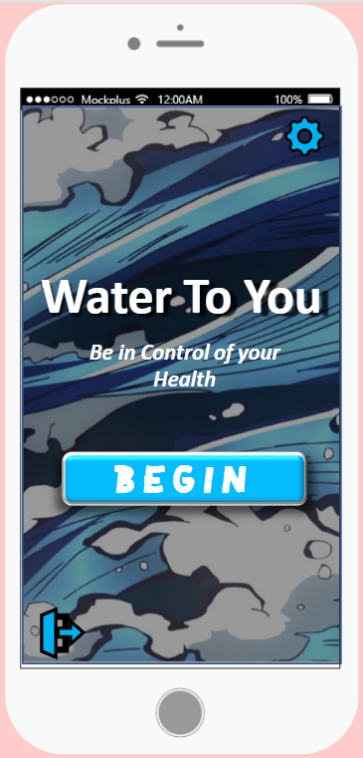

User stated that the background was too ‘*lively’* and was rather distracting.

A suggestion of improvement would be to redesign the water background to be less distracting with fewer colours and ‘*action’* behind the text. I would use a subtle animated ocean background to simplify the colour and animation and visually make the user feel calmer.

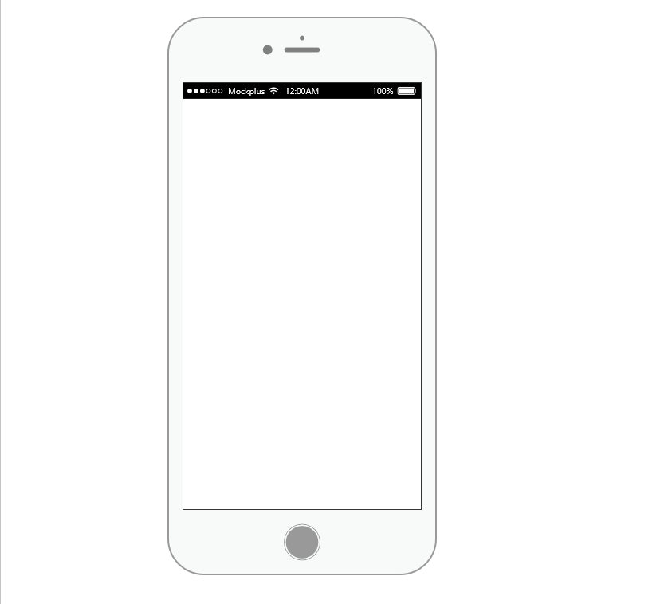

BEGIN

**Water To You**

***Be in Control of your Health***



Screen

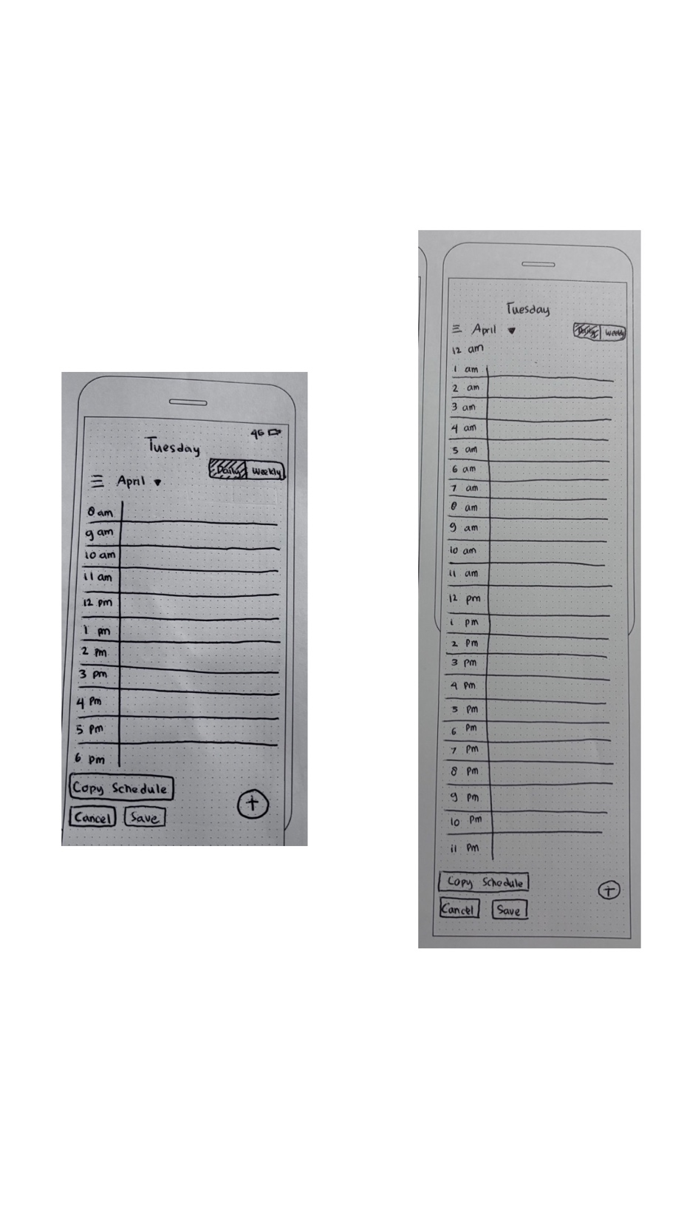

Figure 1 first improvement “screen 4”

User Feedback:

User stated that the schedule should allow entries beyond typical 9–5 hours to suit night or irregular workers.

Recommendation:

Extend the daily timeline to 24 hours so users can schedule sit/stand sessions during any time, increasing inclusivity for varied work style

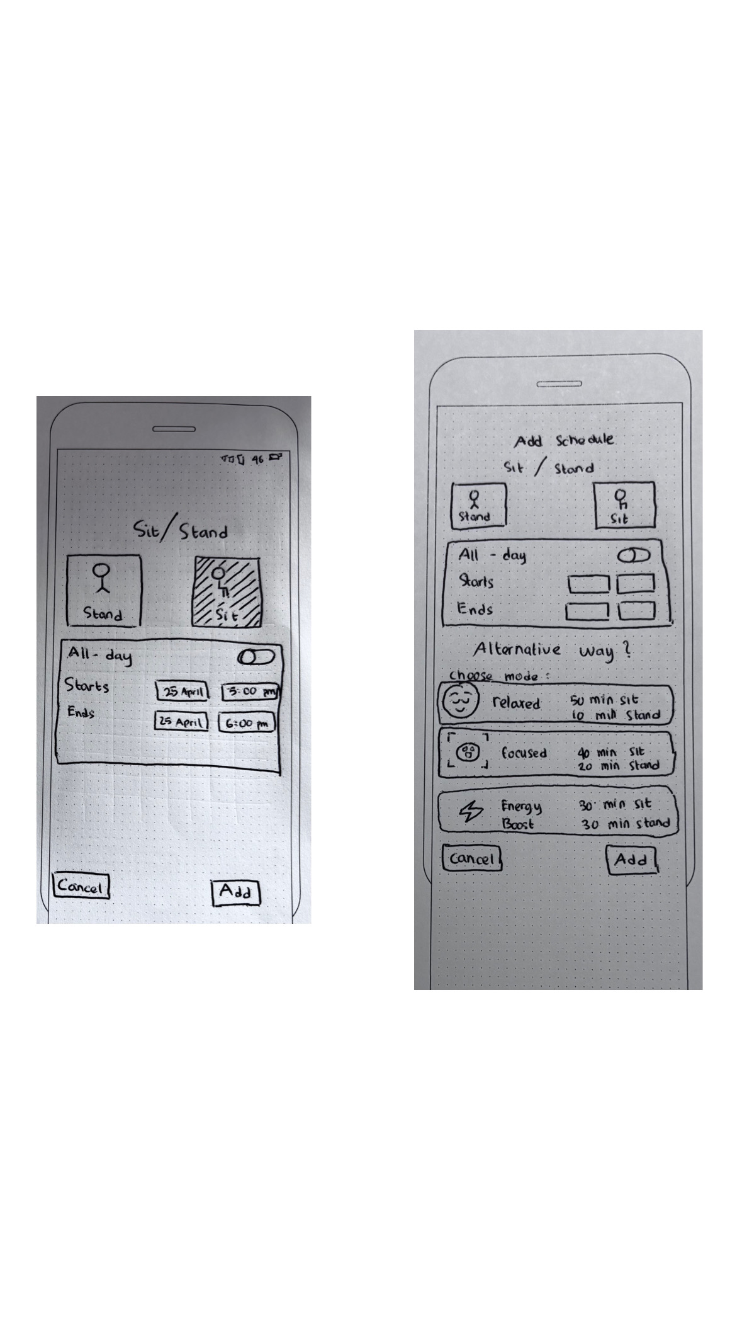

User Feedback:

User suggested having a quicker way to set a schedule without customizing every detail.

Recommendation:

Include preset schedules like “Focus Mode” or “Balanced Routine” for users who prefer minimal setup. This supports flexibility and lowers interaction effort.

Figure 2 second improvement “screen 5”

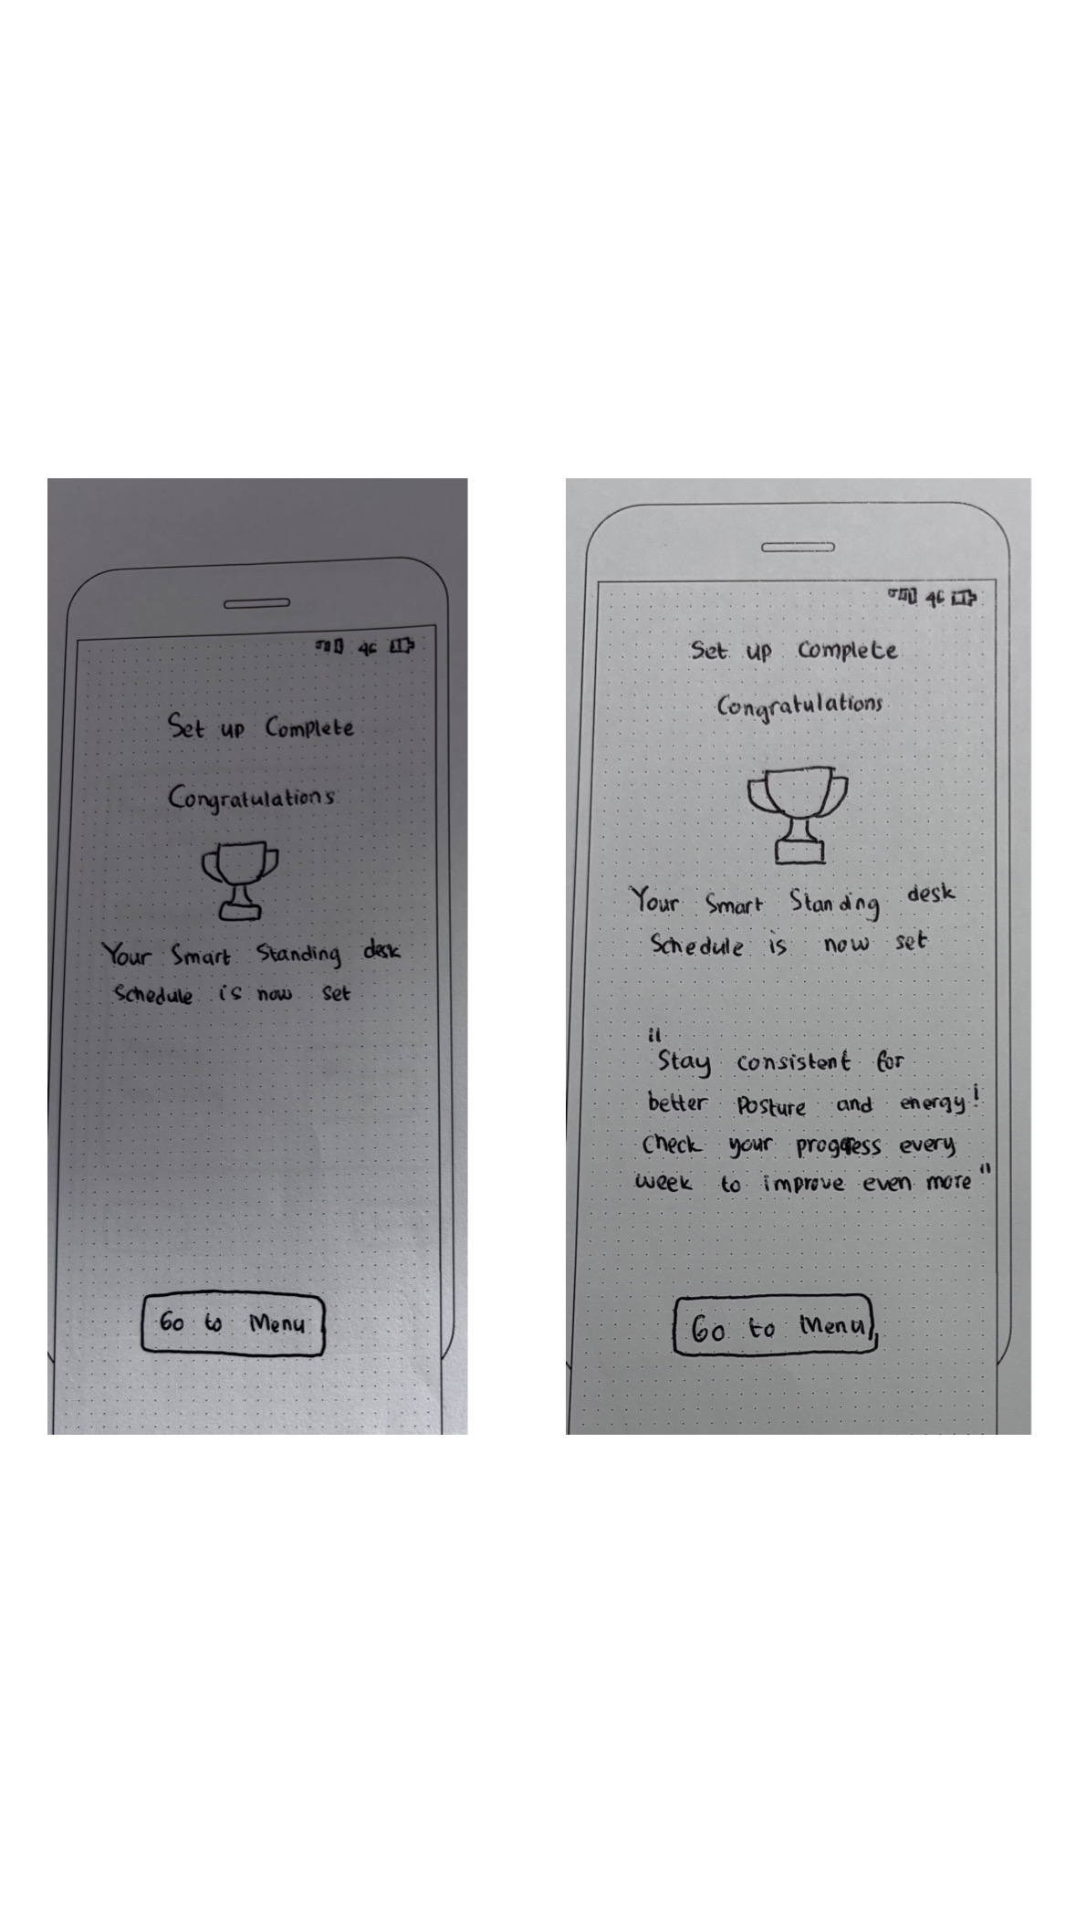

User Feedback:

User appreciated being able to create a schedule but wanted more feedback after doing so.

Recommendation:

Add a confirmation message or tip (e.g., “New schedule saved! Don’t forget to turn on reminders”) to reassure users and guide next steps, enhancing clarity and flow.



Figure 3 third improvement “screen 10”

# Section 7: Appendix

1. Include images of all your paper (and digital) prototype screen designs. Number each so they match the screen numbers in the Heuristic Evaluation Sheet.
2. Include photos of the prototype being used during the evaluation process and of the testing set-up.
3. Include the informed consent form signed both by you and your participant before starting the test.
4. Include a declaration of individual use of Gen AI (Microsoft 365 Copilot), if applicable. This does not include the use of Gen AI for the group persona, which has already been declared in a previous submission. Refer to the Canvas page *Use of Generative AI in this subject* for details on how to declare the use of Gen AI in this subject.

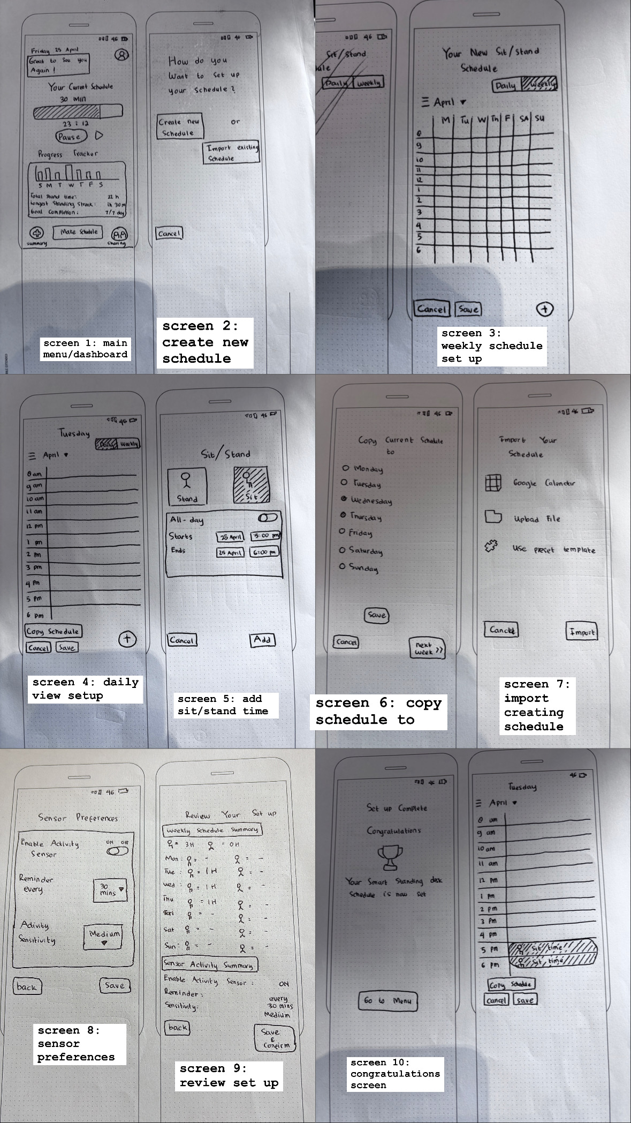

Figure 4 paper prototypes

# Informed consent to participation

I agree to participate in the study conducted by Yafie as part of assignment work in the Fundamentals of Interaction Design subject at the University of Technology Sydney.

I understand that the purpose of this study is to gain insight into participants’ views and experiences on setting up and using a sit/stand desk wellness app prototype.

I understand that my participation in this research will involve completing simple tasks using a paper prototype, speaking my thoughts aloud while interacting with the screens, and being recorded for observational and evaluation purposes.

I might be inconvenienced by the time required to be involved in this study, but no other harm is likely to result from my participation.

I understand that the research activity may require a recording in audio, video, or otherwise for help with transcription.

I hereby give consent to the recording of my activity.

I am aware that I can contact the researcher, Yafie Farabi (phone: 0431 432 649, email: Yafie.farabi@student.uts.edu.au), or the subject coordinator, Alejandra Mery Keitel ( email: [alejandra.merykeitel@uts.edu.au](mailto:alejandra.merykeitel@uts.edu.au)), if I have any concerns about the research.

I also understand that I am free to withdraw my participation from this study at any time I wish, without consequences, and without giving a reason. I will not be penalised in any way for declining to take part in any stage of the research.

I agree that Yafie Farabi has answered all my questions fully and clearly.

I agree that the research data gathered from this study will be submitted for academic purposes in a form that does not identify me in any way.

________________________________________ 28 / 04 / 2025



Name and Signature (participant) Date signed

________________________________________ 28 / 04 / 2025



Name and Signature (researcher) Date signed